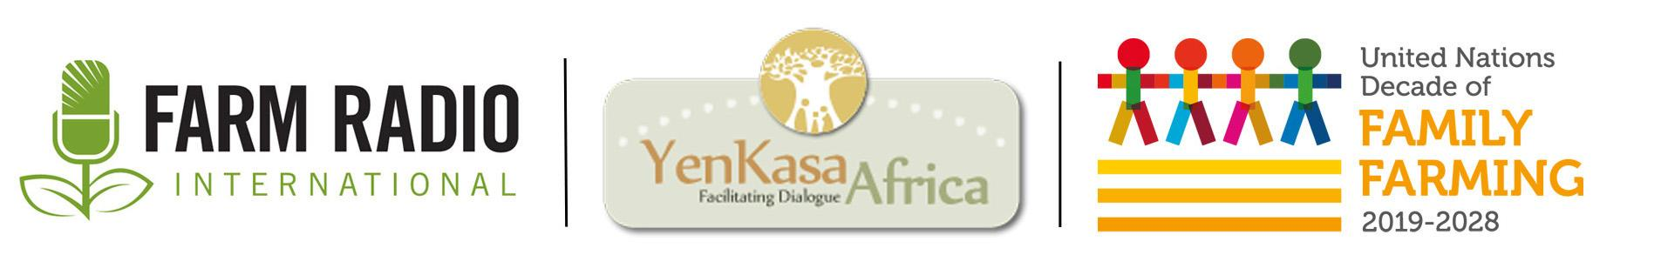
Radio spots
September 2020
__________________________________________________________________________

Radio spots on UNDFF – part two ____________________________________________________

Spot #1

Are you aware of all the benefits of getting to know your local farmer? When you know your farmer, you can trust the quality of the food your family eats! You can trust that the high-quality food will nourish your daughters and sons and enable them to succeed in school. So talk to your local farmer to learn about their farming practices and what makes their food so nutritious. Learn about your farmers' challenges and interests. Because farmers are important contributors to your health and happiness. This is the UN Decade of Family Farming and this station is proud to be a Voice for Family Farmers

Spot #2

The next time you go to the market to buy food, think about the farmers who grew those potatoes, tomatoes, cassava, or rice. By supporting local farmers, you support your local economy. You support the market vendor who sells the food, the workers who transported the food from field to market, and the labourers who processed the tomatoes into paste or the cassava into flour. And you also support the farmer who grew the food in their field. When you buy food from your local farmer, you help the economy go round and round, helping everyone! So support your local farmer—and create virtuous circles! This station is proud to be a Voice for Family Farmers and part of the awareness campaign for the UN Decade of Family Farming.

Spot #3

We all want the people in our communities—our towns, villages, and cities—to be healthy, happy, well-fed, and resilient. A healthy food system is essential for that, including the farmers who grow your food and everyone who helps that food travel from the field to your home. The COVID-19 pandemic has challenged everyone, making work, travel, and life more difficult so we can keep safe. Farmers are feeling this stress too, as they continue growing food that nourishes their families and yours. Tell policy-makers to support farmers for a stronger recovery from the current crisis and a more resilient economy. This station is proud to be a Voice for Family Farmers and part of the awareness campaign for the UN Decade of Family Farming.

Spot #4

Farmers! Can you count the benefits of joining a farmers’ group on one hand? On two hands? On both hands and feet? Farmers’ groups can help increase your income, decrease your costs, give you the latest farming information, represent you with big buyers and input dealers—and even fight to get the roads fixed! Farmers’ groups are your representative with local, regional, and national governments. They work for you and represent your interests. Farmers’ groups exist to listen to your concerns—and to work on making your ideas and solutions a reality. So don’t miss out! Join a local farmers' group that will fight for family farmers like you—and raise your voices and concerns so that they’re heard far beyond your community. This station is proud to be a Voice for Family Farmers and part of the awareness campaign for the UN Decade of Family Farming

Spot #5

Working on your farm, in your factory, or at the market can feel a long way away from the offices of policy-makers and the United Nations. But you can have a voice in those discussions through your local and national farmer organizations. These organizations speak for you, support you, and listen to your ideas. In (THIS REGION), (INSERT NAME OF FARMER ORGANIZATION) speaks for you. So get in touch with them to share your opinions. This is the UN Decade of Family Farmers and this station is proud to be part of the awareness campaign, A Voice for Family Farmers.

Spot # 6

Farmers, marketing your produce isn’t easy. But when farmers work together, everyone wins! Your farmers group can help you do that. Working with other farmers helps you profit from markets that individual farmers can’t access. Your group can also help you sharpen your business skills, find financing, identify better opportunities, and hear today’s market information today. When you know what the market needs and exactly how you and other farmers can best supply it, everyone profits! This station is proud to be a Voice for Family Farmers and part of the awareness campaign for the UN Decade of Family Farming.

Spot # 7

Farmers work hard to produce a good crop. After all their work, they sometimes feel that buyers pay them less than they need and deserve. But buyers and market vendors also need to make a profit, too. What can be done about this situation? Share your market information so that farmers, buyers, vendors, and even food processors know what crops will fetch a good price and where to invest time and effort. Good information helps everyone make good plans and good profits. This station is proud to be a Voice for Family Farmers and part of the awareness campaign for the UN Decade of Family Farming

Acknowledgements
This resource was supported by YenKasa Africa, with funding from the UN’s Food and Agriculture Organization. YenKasa Africa is a platform to enhance knowledge and experience sharing to support agriculture and rural development in sub-Saharan Africa.
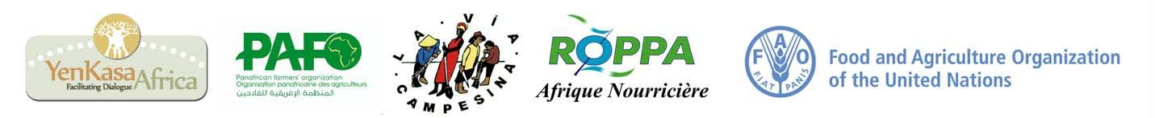
Farm Radio International is a communication partner for the UN Decade of Family Farming 2019-2028 in Africa.

