Pack 114
Type: Broadcaster how-to guide
May 2020

_________________________________________________________________________
BH2 – How broadcasters can stay safe during the COVID-19 pandemic
_________________________________________________________________________

What is COVID-19?
COVID-19 is an infectious disease caused by the new coronavirus. It originated in Wuhan, China in December 2019 and quickly spread around the world. The World Health Organization declared COVID-19 a global health pandemic in March 2020.
How is it spread?
People catch COVID-19 from others who have the virus. The disease is spread through droplets produced when infected people cough, sneeze, or exhale. These droplets can be inhaled by people nearby or land on nearby objects and surfaces. When people inhale droplets or touch contaminated objects or surfaces, then touch their eyes, nose, or mouth, they can be infected.
What are the symptoms of infection?
The most common symptoms of COVID-19 are fever, tiredness, and dry cough. Symptoms are usually mild and begin gradually. Some infected people have no symptoms and don't feel ill. Most people (about 80%) recover without special treatment. About one in six people who are infected become seriously ill. Older people and people with underlying conditions like heart problems, diabetes, and high blood pressure are more likely to become seriously ill. People with fever, cough, and difficulty breathing should seek medical attention.
What do I need to know about staying safe during the COVID-19 pandemic?
(Learn more about these and other points in the Details section below.)

- What are the risks for broadcasters during the COVID-19 pandemic?
- How can broadcasters fight misinformation surrounding COVID-19?
- How can broadcasters prevent themselves and others from becoming infected?
- How can broadcasters stay safe while continuing to report on the pandemic and other issues?
- What should broadcasters do if they get sick?
- How can broadcasters maintain their mental health during the pandemic?

- What are the risks for broadcasters during the COVID-19 pandemic?
Some broadcasters may be at a heightened risk of contracting COVID-19 because they are required to communicate “live” with many people in various settings. Some broadcasters might be required to report from “hot spots” like government offices, hospitals, clinics, and transit hubs, that could increase the chances of becoming infected with the virus. However, there are a number of preventative measures that broadcasters can and should take to protect themselves (see section #3).
- How can broadcasters fight misinformation surrounding COVID-19?
Unfortunately, false information about COVID-19 can spread even faster than the virus itself. Broadcasters have an important role to play in combatting misinformation surrounding the spread of the virus, the symptoms, treatments, and other aspects of the COVID-19 situation.
First, broadcasters should thoroughly fact check all information about COVID-19 and ensure that the information comes from a reputable and trusted source like the World Health Organization (WHO) or public health officials. Second, broadcasters should address any misinformation that has spread in their community by inviting a reliable health expert to debunk any myths and offer accurate information. Third, broadcasters should invite listeners to think critically about the information they hear and encourage them not to spread information they don’t know to be true. For more information, read FRI’s BH2 on fake news.
Here are some examples of the kinds of disinformation being circulated about COVID-19, along with an explanation of why the information is false or misleading:
- Antibiotics are not effective in preventing and treating COVID-19. Antibiotics do not work against viruses, only bacteria. COVID-19 is a virus and, therefore, antibiotics should not be used to prevent or treat it. However, if you are hospitalized with COVID-19, you may receive antibiotics for other infections.
- Chloroquine is not a cure for COVID-19. Chloroquine is used to treat malaria, and is being tested as a treatment for COVID-19. But it is not a cure, and testing continues. Be careful: while chloroquine is a generally safe medication, there have been some reported cases of negative side effects.
- Being able to hold your breath for 10 seconds or more without coughing or feeling discomfort DOES NOT mean you are free from COVID-19. The World Health Organization advises people who think they might have COVID-19 to stay home and seek medical attention by calling their local health authority. The best way to confirm if you have the COVID-19 virus is with a laboratory test. You cannot confirm it with this breathing exercise, which could even be dangerous.
- There are false rumours that some substances can cure or prevent infection with COVID-19. These include drinking a mix of lemon and baking soda, breathing steam from boiling orange or lemon peels, eating alkaline food, gargling with salt or vinegar water, or using herbal treatments. According to the World Health Organization, the way to prevent being infected with COVID-19 and prevent the virus from spreading is to wash your hands frequently with soap or an alcohol-based sanitizer, maintain at least one metre distance between yourself and someone who is sneezing or coughing, avoid touching your face, and cover your mouth and nose with your elbow or tissue when you cough or sneeze.
Learn more by reading our key information on COVID-19 for broadcasters.
- How can broadcasters prevent themselves and others from becoming infected?
There are a number of basic health guidelines that everyone should adopt to protect themselves and others:
- Wash your hands frequently. Clean your hands regularly and thoroughly with soap and water or an alcohol-based sanitizer. Why? Washing your hands with soap and water or using alcohol-based sanitizer kills viruses on your hands.
- Maintain physical distancing. Try to avoid meeting anyone outside your household in person, but if absolutely necessary, be sure to maintain a distance between one and four metres apart, depending on government guidelines in your country. Why? When someone coughs or sneezes, they spray droplets from their nose or mouth that may contain the virus. If you are too close, you may breathe in the droplets.
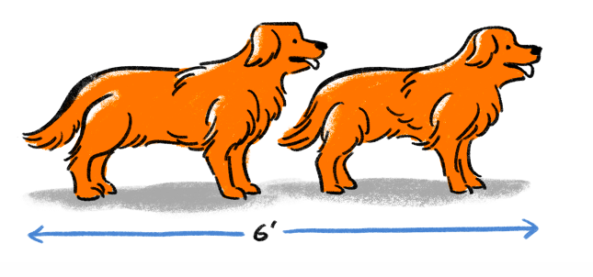
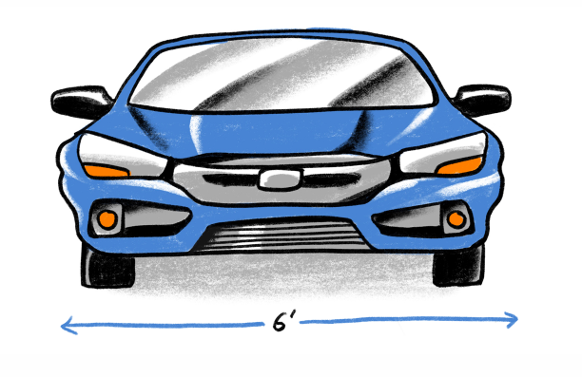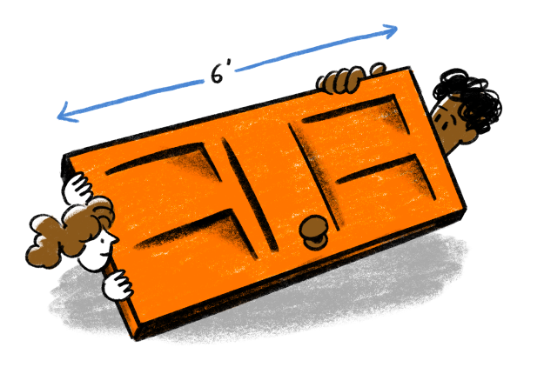
Image source: https://www.cnn.com/2020/03/24/health/six-feet-social-distance-explainer-coronavirus-wellness/index.html
- Avoid touching your eyes, nose, and mouth. Why? Hands touch many surfaces and can pick up viruses. Once contaminated, your hands can transfer the virus to your eyes, nose, or mouth. From there, it can enter your body and make you sick.
- Practice good respiratory hygiene. When you cough or sneeze, cover your mouth and nose with your bent elbow or a tissue. Dispose of the used tissue immediately. Why? Droplets spread the virus. By following good respiratory hygiene, you can protect the people around you from COVID-19 and other viruses such as colds and the flu.
- Avoid crowded areas such as markets, other public spaces, and public transport. Why? Being in close proximity to others can increase your risk of becoming infected, particularly because some people may be infected without showing visible symptoms, so it’s best to avoid coming into contact with others until health authorities advise that it is safe. If you need to go out in public, it’s advisable to wear a face mask to protect others and yourself. The virus is spread by coughing and sneezing, so wearing a face mask will help to protect both others and yourself—see the last tip below for more information about how to wear a face mask properly.
- Clean your phone and other objects. Disinfect your hands before and after touching any objects or food items, especially your microphone, recorder, pens and pencils, phone, wallet, or other items you touch regularly throughout the day.
- Practice safe greetings. To avoid COVID-19, it is safest to avoid physical contact when greeting, as in a hug or a handshake. Safe greetings include a wave, a nod, an elbow bump, or a bow.
- Wear a mask. Wearing a mask allows you to breathe normally and avoid spreading saliva droplets when you speak, sneeze, or cough. To properly wear a mask, ensure that it fits securely over the bridge of the nose and the chin. Avoid touching the mask, and only remove it by using the straps, not by touching the front. Wash hands with soap and hot water after removing the mask or use an alcohol-based hand sanitizer (greater than 60% ethanol or 70% isopropanol) Replace the mask with a new, clean, dry mask as soon as it becomes damp. Note: Masks are not a substitute for other prevention measures, and MUST be accompanied by the measures listed above.
Note: Some people can be infected with COVID-19 without showing any symptoms. This means that they can unknowingly pass it on to people who are more at risk. That’s why these health and safety precautions are vital for other people’s safety as well as your own.
- How can broadcasters stay safe while continuing to report on the pandemic and other issues?
There are many ways for broadcasters to protect themselves and continue to work:
- Work from home if you can. This might mean audio editing, conducting phone or WhatsApp interviews, and doing research on your home computer or mobile phone.
- Clean and disinfect your workspace and equipment regularly. If you do have to go into the station, clean your equipment and workspace regularly with an alcohol-based solution that contains greater than 60% ethanol or 70% isopropanol. You should also clean your home or office workspace regularly, and anytime another person or object comes into contact with the surfaces you touch. If possible, use a table-top microphone instead of a hand-held microphone. To properly clean a microphone (see the diagram below), detach the head basket, remove the sponge (which acts as a cover and is not vital to the functioning of the microphone), and replace it or clean it with a sanitizer or alcohol-based solution. You must also disinfect the body of the microphone, that is, the handle or base and any buttons and switches.
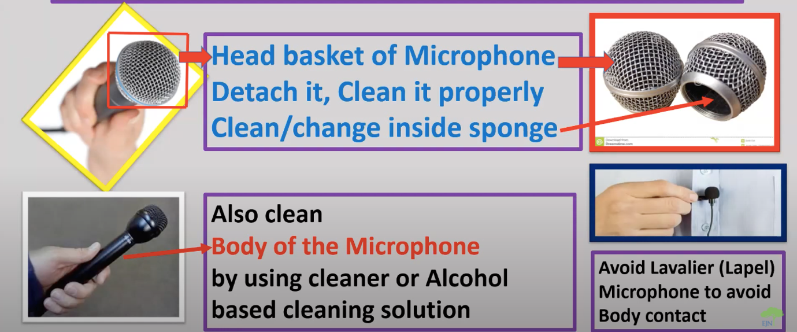
Photo courtesy of Earth Journalism Network
- Use separate microphones. Try to avoid meeting anyone in person, but if this is absolutely necessary, use separate microphones for yourself and your interview subject. Sanitize them with alcohol and a washable cloth before and after use.
- Fight misinformation. Accurate reporting is one of the most effective tools to combat misinformation about COVID-19. Broadcasters should fact-check thoroughly, report without bias, and resist stereotyping by avoiding unnecessary references to race, nationality, or ethnic origin when talking about the virus. For more on recognizing and countering fake news, see FRIs BH2 on fake news.
- If you must conduct face-to-face interviews, respect physical distancing by using a device like a long selfie-stick or pole for face-to-face interviews. If it’s not possible to follow physical distancing, consider cancelling the interview. As well as keeping physical distance, stand at an angle to interviewees rather than face-on. When possible, conduct in-person interviews outdoors. If indoor interviews are necessary, choose a location with some kind of airflow, for example, near an open window.
- Consider staying away from sick people. Though hospitals and health centres may be “where the big story is,” consider not visiting to maintain your own health and safety. You might choose to cover other stories related to COVID-19. This may mean avoiding health centres, testing centres, morgues, quarantine zones, densely packed (urban) areas, or the homes of sick people. Naturally, you will need to make this decision together with the management of your radio station.
- Interacting with older people and those with underlying medical conditions. These groups of people are at greater risk from COVID-19, so you may choose to conduct phone or WhatsApp interviews with them. If you fall into one of these categories, you may decide it’s safest to stay at home.
- Make plans with your colleagues and your family. Discuss your management team’s plans if they need to assist and support you if you fall ill while on assignment, remembering that you may need to self-isolate and/or may be grounded in a quarantine/lockdown zone for an extended period of time.
For more information about safely reporting on COVID-19, read FRI’s BH2 on working remotely for radio broadcasters.

- What should broadcasters do if they get sick?
Stay home and isolate yourself from others, including family members. Seek medical attention only if absolutely necessary (if you have worsening symptoms such as difficulty breathing, fever, and persistent dry cough).
- How can broadcasters maintain their mental health during the pandemic?
The job of a radio broadcaster can be especially stressful during the time of COVID-19, as broadcasters continue to report on the spread of the virus, the deaths associated with it, and the restrictions imposed on people and communities to keep them safe. It’s important to consider your mental health as well as your physical health and to take care of yourself to ensure that you can continue to do your job effectively. Here are some strategies:
- Take regular breaks and pay attention to your energy level and fatigue. At the end of a work day, try to relax and slow down to avoid burnout.
- Management should regularly check in with staff and offer guidance and support when necessary. Broadcasters should tell managers if they feel unsafe on a particular assignment.
- When covering COVID-19, rejuvenate your mental health and lowering your stress levels by keeping familiar, comfortable things near you to remind you of “normal” life, like a picture of your family and friends.
- Exercise regularly, eat healthy food, get enough sleep, and drink plenty of water.
- Try to maintain a regular routine as much as possible.

Where else can I learn about broadcaster health and safety during COVID-19?
Committee to Protect Journalists, 2020. CPJ Safety Advisory: Covering the coronavirus outbreak. https://cpj.org/2020/02/cpj-safety-advisory-covering-the-coronavirus-outbr.php
Harrison, Sylvie, and Cuddeford, Vijay, 2017. BH2: How to plan and produce effective emergency response programming for farmers. Farm Radio International. http://scripts.farmradio.fm/radio-resource-packs/105-farm-radio-resource-pack/plan-produce-effective-emergency-response-programming-farmers/
Lewis, Katya Podkovyroff, 2020. Mental and physical health of reporters during COVID-19. https://ijnet.org/en/story/mental-and-physical-health-reporters-during-covid-19

Acknowledgements
Contributed by: Maxine Betteridge-Moes, freelance journalist and former Broadcaster Resources Advisor with FRI Ghana.
This resource is undertaken with the financial support of the Government of Canada provided through Global Affairs Canada.

