Pack 114
Type: Broadcaster how-to guide
May 2020
____________________________________________________

BH2: Working remotely as a radio broadcaster ____________________________________________________
Why is it important to know how to work remotely as a radio broadcaster?
Sometimes, radio broadcasters can’t report a story on-location or by meeting face-to-face with the people involved. This is particularly true during the COVID-19 pandemic when governments around the world have enacted distancing policies that require individuals to keep at least one metre away from everybody except those in their household to slow the spread of the virus.
But news media are considered an essential service in most countries, and this means that radio broadcasters will need to practise safe methods of continuing to report, but from a distance.
What are “essential services” and how do they apply to radio broadcasting?
Different governments may have different criteria for deciding what services are essential, but essential services will usually include healthcare, food and agriculture, law enforcement, some retail services, and other businesses that are absolutely necessary for everyday life. Broadcasting is considered an essential service in most countries because it is vital that people receive accurate and up-to-date information through radio, TV, the internet, print, and other media. This means that the role of radio stations and radio broadcasters to deliver timely and accurate information that is relevant to both male and female African farmers and their families is more important than ever.
To learn more about how broadcasters can effectively respond in an emergency, read FRI’s Broadcaster how-to guide on planning and producing effective emergency response for farmers, and our BH2 on staying safe as a broadcaster during the COVID-19 pandemic.
What are the challenges of working remotely?
Transitioning from a radio station to a home or other remote work environment can be difficult, especially given that a lot of the advice found online may not address the unique challenges faced by rural African broadcasters. These challenges can include less reliable phone or internet service outside the station, unavailability of staff to address technical issues, coping with stress and mental health, interruptions from family members when working at home, and maintaining a loyal audience despite changes to regular programming and broadcasting methods. Fortunately, radio is a highly adaptable medium and broadcasters can make adjustments to their work methods to help them adapt. This BH2 offers detailed information about methods for adapting to remote broadcasting, including budgeting for and investing in reliable internet services, connecting virtually with staff to address technical difficulties, paying attention to your mental health, and using radio formats that keep your listeners engaged, informed, and entertained.

How do I do effective broadcasting remotely? (Learn more about these and other points in the Details section below.)
- Gather equipment and materials to work remotely
- Conduct remote interviews
- Eliminate some radio formats
- Experiment with safer radio formats
- Reuse interviews with previous experts or recordings from past programs
- Reduce the number of staff working at one time
- Conduct remote meetings
- Collaborate on sources and recorded material
- Invest in good internet services to work from home
- Use FRI resources to build your program

Details
- Gather equipment and materials to work remotely
Here is a list of some of the equipment you may need to work remotely. During the COVID-19 crisis, make sure you properly disinfect any equipment you bring home and clean it regularly at home.
- Recorder: Even though you won’t be recording in-person interviews, you can still use your recorder to record phone calls, videos, and other audio footage. To learn more about using a recorder for high quality sound, read FRI’s BH2 on Basic recorder settings.
- Smartphone or tablet: You can use your smartphone or tablet instead of a recorder to conduct and record interviews on apps such as WhatsApp, Skype, and Zoom. Smartphones and tablets are also useful for conducting online research if you don’t have access to a laptop or computer.
- Laptop: If you have access to a laptop or desktop computer at home, you can conduct online research and use audio editing software more easily. If you are unfamiliar with audio software technology, read FRI’s BH2 on recommended tutorials.
- Set up a designated work space: This can help you focus better and separate your work and home life. Even if you are working in a small space with limited materials, try to set aside an area inside your home, compound, or other private space to help you feel more organized. Even if you just set up a desk and chair with your work materials, you will feel more organized.
- Phone credit: It’s important to stock up on phone credit to avoid going out in public. Keep track of how much phone credit you use and have a prior discussion with management about covering the costs associated with working remotely. If they agree, submit a budget and an invoice to your station management.
- Forward incoming calls: If your station has a studio phone, see if incoming calls can be forwarded to your personal phone while you are working at home. If not, practice physical distancing measures at the station and assign one person to answer phone calls and record messages.
- Pen, paper, calculator, etc: Ask management if you can bring office supplies home from the radio station. Or submit a budget to purchase any materials necessary to work from home.
Here are some other ways that management can safely enact physical distancing at work and support staff who work remotely:
- Designate a particular staff member to provide advice on connection difficulties and help those who are unfamiliar with the technical aspects of working from home. This staff member may also help others liaise with service providers.
- Production teams and management should make special efforts to reach out to listeners by phone and through any other means possible to determine whether the audience is still listening. Ask them for feedback and suggestions and encourage them to keep listening throughout the period of the pandemic. Make sure you reach out to women listeners. Some women, have poor access to radio sets and phones. Encourage other listeners to contact these women, including women family members, to ensure that they can interact with the station and by supporting them to interact.
- Management should develop and distribute policies in areas that are affected by COVID-19 to ensure that staff are aware of safety measures and best practices for covering stories during the pandemic. For example, staff should not interview any sources in-person unless absolutely necessary, and should then take appropriate health and safety precautions such as wearing a mask and gloves and standing at least one metre away. If staff are unable to work from home, they should wear a face mask inside the studio at all times. These policies can be distributed via a WhatsApp group chat, a remote meeting, and posted on the wall inside the station.
- Conduct remote interviews
Avoid meeting with interview subjects in person unless absolutely necessary. Instead, do a live phone interview or a pre-recorded interview, and then edit for time and clarity. Many phones don’t have a built-in phone call recorder, so the easiest way to record a phone call is by putting the call on speaker, placing the phone right next to your recorder and recording. You can also use Skype to record phone or video calls directly in the app. As soon as the interview has started, tap the “Start recording” button. When you hang up the call, the recording will appear in the chat window for 30 days. Be sure to download and save it during that period so you don’t lose the recording.
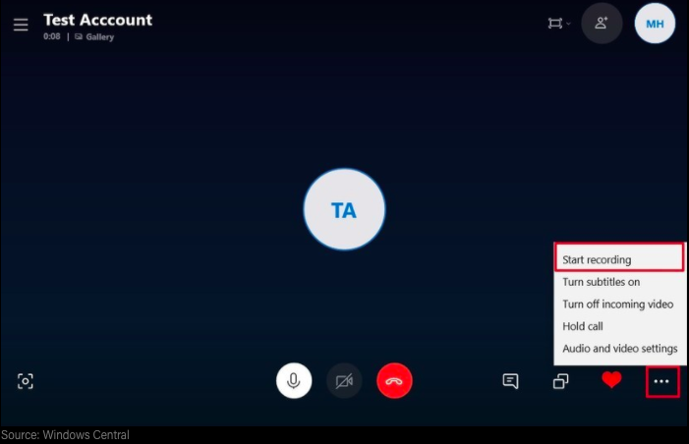
1: Skype Desktop
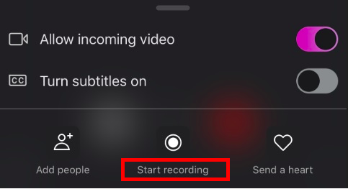
2: Skype Mobile
Below are some tips to keep in mind when conducting remote interviews. You might suggest that the person you are interviewing follows the same advice:
- Turn off your notifications on your phone and ask the other person to do it too. This will prevent unexpected buzzing or beeping during the interview.
- Check the sound level before recording. You may need to ask the interview subject to move to a quiet place. Make sure you are also in a quiet space for the duration of the interview.
- Don’t move around during the interview. This can interrupt service or reception and may make you or the interview subject sound a little out or breath.
- Don’t move your phone or computer during the recording—this can cause unwanted static and noise.
- Don’t do anything else on your phone or computer while conducting the interview (e.g., check emails, send a text message).
- If conducting an interview which will be recorded and aired later, ask your subject to summarize the most important facts or information at the end of the interview. This will give you a good, short sound bite to use in the program. Avoid doing this during a live recording because it could encourage the person to speak for a long time, which would delay the next segment.
- Be prepared, focused, and listen carefully. It can be challenging to conduct an interview without seeing someone’s body language. Allow for some pauses and silences, but make sure you are prepared with all your follow-up questions. But avoid long silences. The interviewee might think you have dropped the call, or take it as a sign to continue speaking, both of which can detract from the interview.
As with any interview, whether remote or in-person, it’s important to prepare a list of questions to guide you. Don’t be afraid to ask your interviewee to clarify or further explain any complicated ideas or topics, or any responses which are unclear or ambivalent. If you are confused, your listeners probably will be too! It’s important to engage the interviewee respectfully by asking well-thought out and researched questions and listening carefully to their answers, including questions that address issues related to gender equality (for example, the increased rates of domestic violence during the COVID-19 pandemic, and women’s increased risk of infection as front- line workers). Keep the interview on topic by asking questions that go deeper and broader. If necessary, edit the interview down to the essence while maintaining a fair, accurate, and balanced representation of what was said. Make sure that all provided is specifically adapted to the differing needs of women and men.
Audio editing involves choosing what to include and exclude based on the focus of the story and the information needs of your audience. When editing a recorded phone call, as with an in-person interview, basic edits include taking out any “ums” and “ahs” or other unnecessary details to ensure the recording is clear and concise. But you will need to listen back to the entire interview, decide on a focus to help guide you on what to keep and what to delete, choose a production format (e.g., short clips linked together, interview or single voice narrative), and arrange the flow of the audio recording to make logical sense. These steps will help you develop radio content from home that is important, effective, and entertaining.
Learn more by reading FRI’s Broadcaster how-to guides on audio editing and interviewing techniques.
- Eliminate some radio formats
Some radio formats are not safe to produce during the COVID-19 pandemic because they require meeting with people in person, which increases the chance of spreading infection. You might want to eliminate mini-documentaries, vox pops, and public games while physical distancing policies are still in place.
- Experiment with safer radio formats
Try incorporating radio formats that are entertaining and informative without putting yourself and others at risk. Here are some examples:
1. Conference call panel discussion: You can invite multiple people to participate in a panel discussion by using the conference call feature on your mobile phone or landline. Depending on the technology that’s available while you’re working remotely, you might use apps like Skype, Google Hangouts, or Zoom to convene your panelists. Before airing the live program, try to arrange a trial run with all participants so they can introduce themselves and say a little bit about their background since they may not have met in person. Make sure you ensure there is a balance of men and women on your panel and consider including a gender equality expert.
2. Tape talk: This storytelling format is a conversation between a host and an reporter which is part live interview and part recorded voice and sound. The host interviews a reporter and, as part of his or her response to the host’s questions, the reporter uses audio clips to tell the story. Tape talks can be produced quickly, they can be flexible in length, making them more descriptive, and they give the “live” sound of a reporter in the field, even when the interview is pre-recorded.
3. Phone-in quiz: A radio quiz can be very entertaining and encourage listener participation. The easiest and most effective format for a radio quiz is to ask either true or false questions or multiple choice questions—or a mixture of both. The respondent who gives the most correct responses is the winner. There are different methods for posing quiz questions. One way is to pose the same question to all participants, who must answer as fast as they can. Another way is to ask each participant separate questions and give them a set amount of time to answer. However you run the quiz, the winner could receive a small prize from the station, or simply ear the title of Quizmaster. In order to maintain physical distancing, you may decide to call out to pre-selected participants or have listeners phone in to answer the questions. Make sure you use specific measures to encourage women to participate, for example by creating women-only phone lines, sharing more information about how to participate, and advertising your eagerness to hear women’s comments/answers as well as men’s.
4. WhatsApp Voice notes: Instead of recording vox pops in person, ask listeners to record a short voice note using the voice-record feature on WhatsApp. To do this, simply press and hold the microphone icon to the right of the keyboard in a WhatsApp chat window, record your voice, release your finger, and tap the arrow to send the recording to a designated phone line. The broadcaster who receives the voice note can save and download it, edit if necessary, and then play it on air.
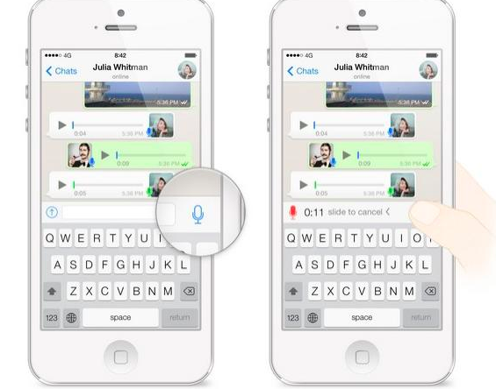
5. Dramas: It is possible to produce a radio drama while maintaining safe physical distancing guidelines. Make sure that every actor has their own microphone and is standing at least one metre apart. Actors should also wear gloves and masks if possible. Try to set up in a big room (e.g., an empty classroom or community hall) or outdoor space —this will also help you capture ambient, natural sound for some scenes. These restrictions may require you to produce a shorter, simpler drama, but may also help engage listeners to present a variety of formats on air to share important information about COVID-19.
For a fuller list of formats, read FRI’s BH2 on radio formats.
- Reuse interviews with previous experts or recordings from past programs
It might be difficult to conduct new recordings from home or from the studio, so it’s worth revisiting past recordings and interviews to re-use some of the material. Contact reliable experts on the phone for updated interviews, but avoid meeting with new interview subjects in person. When reusing an old recording or referencing an old interview, be sure to explain to listeners that the interview is not new and try to get in touch with the same interview subject to provide updates. Ask if their opinion has changed or if there is a new expert on the matter who you should speak with. If the information has not changed, ask if there is anything else about the topic that might be important for listeners to know. Once you have gathered these new details, mention them again at the end of the interview and remind the audience for a second time that the interview was recorded at an earlier date.
- Reduce the number of staff working at one time
Speak to management about implementing physical distancing policies at the radio station. This might mean having only one person in the recording booth at a time and one receptionist at the front desk. The radio station should not be open to the public and listeners should be encouraged to phone in to the station rather than visit in person. Broadcasters should be encouraged to work from home wherever possible. Those that cannot work from home should try to work in staggered shifts to limit physical contact with other staff.
It’s important for those in the station to wear masks at all times and regularly disinfect surfaces such as desks, computers, telephones, and microphones with an alcohol-based solution greater than 60% ethanol or 70% isopropanol. Hosts and technicians should thoroughly disinfect all equipment and surfaces inside the studio before and after their program airs to ensure safety for themselves and others.
Honouring physical distancing measures and working remotely can have a significant impact on people’s mental health. As a radio broadcaster, it’s important to consider your mental health as well as your physical health and to take care of yourself to ensure that you can continue to do your job effectively. Here are some strategies:
- Take regular breaks and pay attention to your energy level and fatigue. At the end of a work day, try to relax and slow down to avoid burnout.
- Management should regularly check in with staff and offer guidance and support when necessary. Support may be something as simple as a phone call to check in, offering encouragement, listen to challenges and concerns and praising good work. Broadcasters should tell managers if they feel unsafe on a particular assignment.
- When covering COVID-19, boost your mental health by keeping familiar, comfortable things near you to remind you of “normal” life, like a picture of your family and friends.
- Exercise regularly, eat healthy food, get enough sleep, and drink plenty of water.
- Try to maintain a regular routine as much as possible.

- Conduct remote meetings
If you work as part of a team, you will need to hold production and other kinds of meetings remotely before airing the program. Find a free virtual platform to conduct the meeting (WhatsApp, Zoom, Skype, Google Hangouts, etc.) and use the audio function only to reduce data usage and cost. Make a clear agenda for the meeting and email a copy to all participants beforehand. See the example below:
Agenda for production meeting

Topic | Details
Issues for all staff | - Check in, discuss challenges and successes of working remotely
Feedback from last program | - What went well, what can be improved, what was done to ensure that women, as well as men, have access to quality information that is relevant to their realities.
Departmental progress reports | - Ask a member of each department (production, technical, hosting, management, etc.) to provide updates on their work for the upcoming program
Scheduling and deadlines | - Delegate tasks such as research, interviewing, audio editing, drafting a run sheet, etc., and set clear deadlines
Any other business | - Close the meeting with any other questions, comments or concerns from staff
Decide as a team how often you need to conduct virtual meetings to ensure smooth production and general operation of the station. Be mindful of personal and family commitments team members face, for example, those who need to take care of young children or ill family members.
Note: it’s important to create a program run sheet to be sent to all members of the production team in advance of the program because it enables the host, producer, technician, and any others involved in the program to coordinate their actions around a shared schedule. It’s also an important tool to keep all your segments organized and on time. For more on this subject, read FRI’s BH2 on developing a run sheet.
- Collaborate on sources and recorded material
Under normal circumstances, many radio broadcasters will be unlikely to share their recorded material with others because, unless otherwise stated, stations only broadcast original reports. As a radio journalist, it is unethical and misleading to produce a program or segment that relies on recorded interviews or sound bites that you or your team did not record without informing your audience. The role of a journalist is to bear witness and therefore they should strive for original content and authentic reporting whenever possible.
However, with emergency response programming, it’s important that your audience gets the information it needs by all means necessary. This might mean collaborating with other radio broadcasters at your station or at another station to digitally share sources, research, recorded material or even to co-produce a program about the situation in your area. For example, you could share information from or about a health official in your area who has set up a local testing centre or is distributing face masks. Perhaps you could share a song from a local musician about protecting yourself from COVID-19. You might even share this BH2 if you found it useful! As long as you credit the source of the information, it’s useful and appropriate to share it.
You might want to consult with other broadcasters in your area, region, or country through existing groups. The FRI WhatsApp group in your home country is an excellent platform for radio broadcasters to learn from and share with one another. Contact the FRI country representative in your home country to be added to the group, or email radio@farmradio.org and state your name, country, and radio station.
- Invest in good internet services to work from home
With the closure of non-essential businesses around the world, it may become more difficult to purchase data packages for your mobile phone or computer. If possible, invest in reliable internet service so that you can work from home for several days or weeks at a time. Do not spend any money unless you have permission or pre-authorization from management for reimbursement. If it is not possible for your station to fund internet costs while you work remotely, management should create a schedule that places reporters at the station in shifts that enable physical distancing. See sections #6 and #7 above.
See the example below of a budget for phone credit that a Ghanaian broadcaster could submit to station management.
ITEM | DETAILS | COST
Phone calling credit | MTN call package for 100 daytime minutes, unlimited evenings and weekends | 10 Ghana cedis (GHS)
Phone data package | MTN data package 4GB for 30 days | 40 GHS
TOTAL COST: 50 GHS

- Use FRI resources to build your program
FRI has a vast collection of online radio resources, including interview and drama scripts, backgrounders on agricultural and other topics (including resources related to gender issues), broadcaster how-to guides, farmer stories, and much more to help you put together a high-quality radio program every week. You can browse all of our tools and resources by visiting https://farmradio.org/radio-resources/

Where else can I learn about distance methods?
Children’s Radio Foundation. COVID-19: Remote Reporting & Broadcast Tool Kit. April 2020. https://childrensradiofoundation.org/covid-19-remote-reporting-broadcast-toolkit/
Committee to Project Journalists. CPJ Safety Advisory: Covering the coronavirus outbreak. 6 April 2020. https://cpj.org/2020/02/cpj-safety-advisory-covering-the-coronavirus-outbr.php
Earth Journalism Network. Webinar: Staying safe while reporting on COVID-19. 15 April 2020. https://www.youtube.com/watch?v=KEcBYPGh8b0&feature=youtu.be
Wangui, Irene. Resources for African Journalists covering the pandemic. International Journalists Network. 9 April 2020. https://ijnet.org/en/story/resources-african-journalists-covering-pandemic

Acknowledgements
Contributed by: Maxine Betteridge-Moes, freelance journalist and former Broadcaster Resources Advisor with FRI Ghana.
This resource is undertaken with the financial support of the Government of Canada provided through Global Affairs Canada.

