Type: Backgrounder
Date: October 2017
Backgrounder: Fall armyworm
- Introduction
The Fall armyworm, which has the scientific name of Spodoptera frugiperda, is a major pest of staple crops. The larvae prefer feeding on young maize plants, but also feed on a range of other crops, including millet, sorghum, rice, wheat, sugar cane, and vegetables. The pest originates from the tropical and sub-tropical regions of North and South America.
Feeding on maize can result in up to 100% crop loss if pest populations are high and no control measures are taken. Larger caterpillars can cause extensive destruction of seedlings and young plants by cutting the stem. Feeding on grain also makes the plant susceptible to fungal attack. Destruction of the silk (see diagram below) results in reduced pollination and formation of grain.
Fall armyworm was first reported in Africa in 2016 and has caused significant damage to maize and other crops, and has great potential for further spread and damage. As of May 2017, it had been reported in 26 African countries.
Researchers have estimated that 13.5 million tonnes of maize could be lost to Fall armyworm in just 14 African countries, which is over 20% of total production. Losses in rice, sugar cane, and sorghum will also be serious. The overall cost of losses in maize, sorghum, rice, and sugar cane in Africa in 2017-2018 is predicted to be more than $13 billion US.
The Fall armyworm is actually a caterpillar rather than a worm, and the adult stage of the pest is a moth. The caterpillar attacks the growing point (the top) of the plant and burrows into the cobs.
There are a number of species of armyworms, including the African armyworm, but the “fall” variety causes the most widespread damage.
For further information: See documents 1 and 3 in the Resource List below.
- What you need to know
Why is this subject important to listeners?
- Fall armyworms are causing major damage to maize and other crops—especially staple crops in the grass family such as sorghum, ryegrass, and pearl millet—which farmers rely on to feed their families across Africa.
- Fall armyworm is spreading to most parts of Africa. Thus, many farmers are at risk.
- The indications are that Fall armyworm will establish itself in Africa and become a long-term pest.
- Because this is a new pest, recommendations for management are evolving and farmers will need to seek information on how to cope.
What are some key facts?
- Fall armyworm caterpillars don’t just attack maize; they can feed on a wide range of crop plants.
- The adult moths lay eggs at night on the lower leaves in tight clusters of 150-200 eggs.
- The caterpillars that cause the damage on plants are most active in the early morning and evening. This is therefore the best time to spray pesticides.
- The Fall armyworm has four life cycle stages: eggs, caterpillar (larvae), pupae, and moths.
- The adult moths are strong fliers and capable of dispersing long distances.

What are the big challenges of Fall armyworm?
- Because Fall Armyworm is a new pest, very little is currently known about its adaptation to conditions in Africa. More research is needed and more awareness as well. National activities and a regional FAO-led plan are being developed to support these activities.
- In the tropics, FAW has the potential to breed continuously throughout the year. This potentially means bigger populations of Fall armyworm and more damage.
- Fall armyworm caterpillars can be difficult to identify as they look similar to other caterpillars.
- The older caterpillars crawl deep into the whorl (see diagram below) or burrow into the maize ears/cobs, making it difficult to reach them with insecticides or biopesticides.
- There are reports that FAW has developed resistance to some chemical pesticides in the countries where it originates.
Is there misinformation about this subject that I should cover?
- Farmers may think the Fall armyworm is the same pest as the African armyworm, known as Spodoptera exempta, or other pests such as African bollworm, Tomato moth caterpillar, and maize stem borer.
- A number of different caterpillars attack maize plants. To identify Fall armyworm, look for an upside down “Y” on the caterpillar’s head and four dots on the second to last body segment for confirmation. (See photos 5 and 6 in the linked document.)
Gender aspects of Fall armyworm
- Women are responsible for performing most farming tasks, including application of pesticides. Given the increased demand on pesticides to protect the crop from FAW, this will mean more exposure to pesticides for women.
Predicted impact of climate change on production
- Fall armyworm is a tropical species adapted to the warmer parts of South America. The optimum temperature for caterpillar development is reported to be 28°C. Therefore, in the tropics, there is a potential for continuous breeding, resulting in four to six generations per year. Whether this will occur in Africa has yet to be confirmed.
For further information: See document 1 in the Resource List below.

- The science of Fall armyworm
- Identifying the Fall armyworm
The Fall armyworm’s life cycle moves from egg to caterpillar (larva) to pupa to moth. (See photo in the link here (300 KB) or click on the link in the email.)
Egg
Eggs are round, and change colour from green to light brown before hatching after 2-7 days. The female lays “egg masses” on a host plant, about 150-200 tiny eggs. They are found on the lower leaves and covered in a felt-like layer of grey-pink scales. Each female can lay more than 1000 eggs in her lifetime. (See photos 1 and 2 in the linked document.)
Caterpillar (larva)
The caterpillars are the stage that causes damage to plants by feeding on soft plant tissues. Caterpillars have stripes down the length of their bodies and dark heads with a pale, upside-down Y-shaped marking on the front. They also have four dark dots on the eighth segment of their bodies. As they mature, caterpillars change from light green to dark brown. They are at their most damaging when they are 3-4 centimetres long. Caterpillars take 2-3 weeks to mature, and then change to pupa. (See photos 3-7 in the linked document.)
Pupa
The pupa is shiny brown and is usually found underground. If the soil is too hard, larvae may web together leaf debris and other material to form a cocoon on the soil surface. The pupa spends 9-13 days inside a loose cocoon underground, then emerges from the cocoon as a moth. (See photo 8 in the linked document.)
Adult moths
Females are slightly bigger than males. The male forewing is mottled (light brown, grey, and straw-coloured), and the female has light colouring. Adults emerge at night, and females use the period before egg-laying to fly for many kilometres before they settle to lay eggs. On average, adults live for 12-14 days. Breeding can be continuous, with four to six generations per year. (See photo 9 in the linked document.)
For further information: See documents 4, 8, and 9 in the Resource List below.

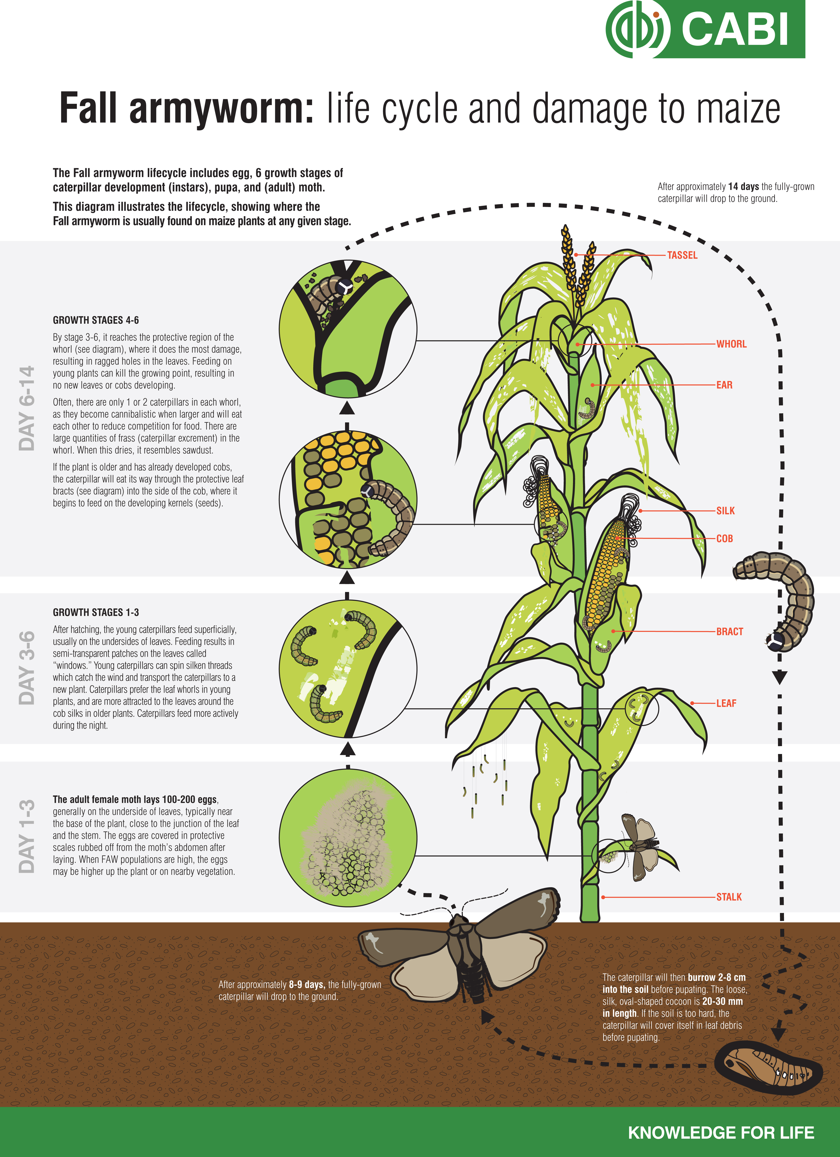

- Differentiating Fall armyworm from other armyworms
It is difficult to tell the difference between Fall armyworm and other armyworms in the field. But there are differences if you look closely. Check:
- Does it have a dark head with a pale, upside-down, Y-shaped marking on the front (see circle in diagram and photo 6 in the linked document)?
- Does each of the body segments have a pattern of four raised spots when seen from above (see circle in diagram)?
- Does it have four dark spots that form a square on the second-to-last body segment (see circle in diagram and photo 5 in the linked document)?
- Is its skin smooth to the touch?
If the answer to these questions is yes, then it is a Fall armyworm caterpillar.
For further information: See document 9 in the Resource List below.
- Symptoms of Fall armyworm feeding and damage
Fall armyworms start by eating plant leaves, then move to the growing points of the plant. During the day, small caterpillars hide in the joints between the leaves and the stem and whorls (see diagram) of the maize and move out during the night to feed on leaves. They may cut the stems of young plants.
As they develop, Fall armyworm move permanently into the whorl (see photo 13 in the linked document). This means that it is difficult to detect early infestations. On young maize plants, damage to the whorl can kill the growing points, which prevents any cobs from forming.
Feeding can cause the whorl and upper leaves to be a mass of holes, ragged edges, and excrement (called “frass.”) Deep feeding in the leaf whorl can destroy developing tassels. (See photos 14 and 16 in the linked document.)
Maize plants can recover from some leaf feeding by caterpillars, particularly when they are young, as long as the caterpillars do not attack the growing point of the plant.
When the plant is large, the Fall armyworm can enter the maize cob directly. The caterpillars usually burrow into the side of the cob (see photo 15 in the linked document), causing damage to grains which can lead to rot.
Fall armyworm infestation causes stunting and destruction of developing tassels and kernels, which reduces grain quality and yield (see photo 16 in the linked document).
For further information: See documents 4 and 8 in the Resource List below.
- How Fall armyworm spreads
Adult moths can fly for long distances, hundreds of kilometres on the wind. This is often how they are introduced to a new area. Also, the large number of eggs they lay enables the pest to quickly establish itself in a new area.
They are also spread by movement of infested plant materials. For example, in Kenya, transporting green maize for roasting is a popular business. If this maize is infested, it contributes to the spread of the pest.
The expansion of maize monoculture across Africa may also help the pest to spread, and contribute to it affecting all farmers, both large-scale and small-scale.
For further information: See documents 8, in Resource List below.

- Advice for farmers

- Monitoring
Starting one week after maize germinates, farmers should monitor for the presence of the pest or symptoms of feeding.
Look for:
- Cream-coloured or grey egg masses on the lower leaves, covered in a felt-like layer of grey-pink scales.
- Light green to dark brown larvae with three thin yellowish white stripes down the back and a distinct white inverted "Y" on the head.
- Larvae covered with yellowish brown frass inside the leaf whorl.
- Patches of small “window panes”—which is where the young caterpillars have chewed on one side of the leaf (see photo 12 in the linked document)—and large ragged and elongated holes in the leaves that emerge from the whorl.
Monitor damage on 10 consecutive plants in 10 randomly selected sites, for a total of 100 plants. When your plants are in the first half of the vegetative phase of growth (the time between germination and flowering), use control practices only if at least 1 in 5 plants show signs of recent damage. If less than 1 in 5 plants show damage, the cost of using control products outweighs the economic benefit of reducing the pest population. When your plants are in the second half of the vegetative phase of growth, use control measures only if 2 in 5 plants show signs of recent damage. If less than 2 in 5 plants show damage at this stage, the cost of using control products is higher than the economic benefit of reducing the pest population.
Where possible, check with your local extension agent to confirm that these thresholds are correct for your location.
For further information: See document 10 in the Resource List below.
- Prevention and management
There are a number of ways to try to manage Fall armyworm in maize and other crops, but because Fall armyworm is a new pest to Africa, none of them are guaranteed to be effective and research is going on to develop more effective solutions.
At the time of writing this document, the approaches listed below were believed to be the most effective.
Recommendations vary between countries. For more precise recommendations on what might work in your area, talk to your extension agent and other experts.

Cultural and manual practices
- Intercropping and crop rotation with non-grass species such as cassava can reduce crop damage.
- Handpick and destroy egg masses and larvae, or collect and drop larvae in hot water.
- Killing one caterpillar prevents the appearance of more than 1500-2000 new caterpillars within less than four weeks.
- Using good quality seeds can increase plant vigour and potentially reduce damage.
- Eliminate grassy weeds in maize fields and nearby as they provide shelter and food for the pest.
- Avoid late planting.
- Put a handful of sand (mixed with lime or ash), sawdust, soil, or grit in the whorl of attacked plants to kill bigger caterpillars.
- Use balanced fertilization to boost plant vigour. In maize, the recommended fertilization rate is 200 kg of NPK at 15:15:15 per ha—but this varies depending on the country.
- Remove and destroy all crop residues.
- Do not move infested plant materials to areas where the pest has not been reported.
Biopesticides
- Biological pesticides, including Bt (Bacillus thuringiensis) sprays are an option in some African countries, though they are not always available or affordable for small-scale farmers. In some countries, governments may provide subsidies or fund spraying programs. If available, apply 1 sachet per 15-litre knapsack of these products twice a week at three-week intervals.
- Neem-based products

Chemical control
Carefully observe your maize to check if there is significant damage. If you decide to use insecticides, try to rotate insecticides with different modes of action to avoid the pest developing resistance to individual insecticides or groups of insecticides. In the list of insecticides below, that would mean rotating products with different IRAC (Insecticide Resistance Action Committee) codes.
For example, in one cycle, you could spray Alpha-cypermethrin (group 3A); in the following cycle, you could change to chlorpyrifos (group 1B), so that you don’t use an insecticide with the same mode of action in consecutive cycles.
A variety of insecticides might be effective against Fall armyworm, including products which contain:
- Alpha-cypermethrin (Pyrethroids, group 3A)
- Chlorantraniliprole (Diamides, group 28)
- Chlorpyrifos (Organophosphates, group 1B)
- Diazinon (Organophosphates, group 1B)
- Diflubenzuron (Benzoylureas, group 15)
- Trichlorfon (Organophosphates, Group 1B)
- Emamectin benzoate (Avermectins, Milbemycins, group 6)
- Indoxacarb (Oxadiazines, group 22A)
- Lambda-cyhalothrin (Pyrethroids, group 3A)
- Lufenuron (Benzoylureas, group 15)
- Spinetoram (Spinosyns, group 5)
- Spinosad (Spinosyns, group 5)
Spray early in the morning or late afternoon, when the caterpillars are most active. Pesticides must be applied at the correct dose. Ensure that the spray gets into the whorl, as this is where the older caterpillars are. Avoid spraying under adverse environmental conditions such as high winds or when it is raining, as this will reduce the effectiveness of the chemicals. Control is best if all farmers in an area apply controls. Fields that aren’t controlled act as breeding grounds for the insect and a source of re-infestation.
Farmers need to know that broad-spectrum pesticides will also kill the natural enemies that control Fall armyworm.
Managing Fall armyworm with insecticides is made more difficult by the caterpillar’s tendency to hide within the whorls and reproductive parts of the host plant, where it is difficult for insecticide sprays to reach them. For this reason, the crop should be sprayed as soon as the pest is noticed on exposed leaf surfaces, and during the early development stages of the larvae.
Caution: Pesticides are poisonous. When using a pesticide, always wear protective clothing and follow the instructions on the product label, including dosage, timing of application, and pre-harvest interval. It’s also important to avoid spraying pesticides near bodies of water, and to avoid spraying at times when bees are actively foraging.
For further information: See documents 1, 3, 4, 8, and 10 in the Resource List below.
The photos mentioned in this document can be found at the following link (300 KB): http://scripts.farmradio.fm/wp-content/uploads/FAW-photos-FINALENGLISH.pdf
Where can I find other resources on this topic?

- P. Abrahams, M. Bateman, T. Beale, V. Clottey, M. Cock, Y. Colmenarez, N. Corniani, R. Day, R. Early, J. Godwin, J. Gomez, P. Gonzalez Moreno, S.T. Murphy, B. Oppong-Mensah, N. Phiri, C. Pratt, S. Silvestri, A. Witt, 2017. Fall Armyworm: Impacts and Implications for Africa. Evidence Note (2), September 2017. CABI.
http://www.invasive-species.org/Uploads/InvasiveSpecies/Fall%20Armyworm%20Evidence%20Note%20September%202017.pdf (4.93 MB)
- Armyworm Network. African armyworm in the press. http://www.lancaster.ac.uk/armyworm/press/
- Armyworm Network. What is fall armyworm? http://www.lancaster.ac.uk/armyworm/what-is-fall-armyworm/
- CABI Invasive Species Compendium, undated. Farm armyworm (Spodoptera frugiperda). Datasheet. http://www.cabi.org/isc/datasheet/29810
- CABI Invasives Spodoptera frugiperda curated Twitter list. https://twitter.com/CABI_Invasives/timelines/831799538025373696
- EPPO Global Database. Photos of Spodoptera frugiperda. https://gd.eppo.int/taxon/LAPHFR/photos
- Gardner, Elliot, May 31, 2017. Fear the fall: the armyworm that threatens food growers everywhere. http://www.foodprocessing-technology.com/features/featurefear-the-fall-the-armyworm-that-threatens-food-growers-everywhere-5829941/
- Ministry of Agriculture (Kenya). Fall armyworm (Spodoptera frugiperda). http://www.kalro.org/sites/default/files/Fall-Army-Worm-brochure-april-2017.pdf (1.93 MB)
- Plantwise: How to identify Fall armyworm. http://www.plantwise.org/FullTextPDF/2017/20177800461.pdf (3.98 MB)
- Plantwise Pest Management Decision Guide: Green List: http://networking.afaas-africa.org/sites/default/files/CABI%20FAW%20Booklet%20%282%29_0.pdf (1.98 MB)
- Poplak, Richard, 2017. Armyworms: The Hungry caterpillar threatening a global food crisis. https://www.theguardian.com/global-development-professionals-network/2017/may/16/armyworms-the-hungry-caterpillar-threatening-a-global-food-crisis The Guardian.
- Slowfood.com, 2017. Fall armyworm: too late to avert disaster? https://www.slowfood.com/fall-armyworm/
- Doctor Armyworm: Fall Armyworm in Africa. https://doctorarmyworm.com/

Key definitions
- Biopesticides: A type of pesticide which is based on micro-organisms or natural products, for example, the bacteria Bacillus thuringensis (Bt), and the fungus Beauveria bassiana, or the neem tree.
- Broad-spectrum insecticides: Insecticides that kill or manage a wide variety of organisms. Opposed to narrow-spectrum insecticides which are designed to kill or manage one or only a few organisms.
- Leaf whorl: An arrangement of sepals, petals, leaves, stipules, or branches that radiate from a single point and surround or wrap around the stem. Whorls consist of at least three elements; a pair of opposite leaves is not called a whorl.
- Natural enemies: Natural enemies of insect pests, also known as biological control agents, include predators, parasitoids, and pathogens.
- Parasitoids: an insect (often a wasp) that completes its larval development within the body of another insect, eventually killing it.
- Pathogens: Micro-organisms which cause diseases.
- Pheromone: A chemical substance produced and released into the environment by an animal, especially a mammal or an insect, that affects the behavior or physiology of others of its species.
- Pheromone traps: A type of insect trap that uses pheromones to lure insects. Sex pheromones and aggregating pheromones are the most common types used. A lure which contains the pheromone is encased in a conventional trap.
- Predators: Insects or other creatures which eat the pest.

Acknowledgements
Contributed by: Vijay Cuddeford, Managing editor, Farm Radio International
Reviewed by: CABI and the Plantwise Program – Tamsin Davis, Dr. Rob Reeder, Dr. Jayne Crozier, Margaret Mulaa, Julian Lamontagne-Godwin.
This backgrounder was produced with the support of CABI (Centre for Agriculture and Biosciences International).

