Pack 106, Item 10
Type: Backgrounder
May 2017

__________________________________________________
Backgrounder: Conservation agriculture
____________________________________________________
Introduction:
Nowadays, many small-scale farmers have difficulty because of climate change. But Conservation agriculture has demonstrated that it is possible for them to succeed in this challenging situation.
Conservation agriculture, or CA, offers simple practices which farmers can use to address the negative impacts of climate change and learn how to “farm with nature.” This may involve adjusting or changing traditional ways of farming to take maximum advantage of the sometimes little or erratic rain and other water available for crops.
Many small-scale farmers think CA can only be understood and practiced by educated people. On the contrary, CA is suitable for farmers with any level of education.
Important practices in CA include crop rotation*, minimal disturbance of the soil, and maintaining soil cover with mulch and living plants throughout the year. For resource-poor farmers, CA involves minimal financial input and less dependence on chemical fertilizers through recommended cover crops and crop rotations. This lack of dependence on external inputs is the reason why CA is practical for small-scale farmers, especially those facing serious labour shortages.
What are some key facts?
- Many small-scale farmers in sub-Saharan Africa are resource-poor and use farming methods that can destroy soil fertility, resulting in poor yields.
- Prolonged tilling with mouldboard ploughs or ridging with hand hoes creates a hardpan* below the loose surface of the soil. This makes soil susceptible to erosion and increases rainwater runoff. Hardpans make it difficult for crops to develop a strong root system.
- Some crops can be classified as “taking crops”*and others as “giving crops,”*depending on whether they extract from or add nutrients to the soil. So a farmer must give good consideration to what type of crop to plant.
- Barriers to CA uptake include attitudes, financial constraints, policies which make uptake difficult, lack of knowledge, and lack of access to knowledgeable extension services.

Predicted impact of climate change on uptake of conservation agriculture
In sub-Saharan Africa, the impact of climate change is often noticed through a reduction in rainfall, or change in the pattern of rainfall. Many practices in CA are designed to maximize the availability of rainwater to crops during their growing period. Planting basins and rip-lines allow more rainwater to collect around plants, and enable roots to access underground moisture. This improved use of available water in CA means that uptake of CA is likely to grow as climate change progresses.

Gender aspects of conservation agriculture
- Many women in sub-Saharan countries are oppressed by negative farming traditions, in relation to land tenure*, choice of crops, and access to market proceeds.
- Some farm implements recommended in CA may not be suitable for women. For example, the Chaka hoe weighs 4-5kg, and ripping requires using oxen.
- Many women are semi-literate and face challenges implementing CA practices that require precise measurements and timing.
Misinformation about conservation agriculture
- Some small-scale farmers believe that CA is labour-intensive. This is sometimes true initially, but labour is often reduced afterwards because farmers work with the same planting basins or rip-lines year after year. CA systems which use herbicides to control weeds reduce labour the most, especially women’s labour.
- Leaving crop residues* in the field is considered untidy. But it has several advantages, including:
  - Acting as mulch that protects the soil from the elements.
  - Decomposing and adding nutrients to the soil.
  - Suppressing the germination and growth of weeds.
- Many farmers believe fields need to be tilled in order to allow water to enter the soil. In fact, keeping soils covered with mulch and/or living plants is far more effective at increasing water infiltration than tillage.
- Some believe that CA does not allow a farmer to rest during the year. However, when planned well, CA actually spreads labour systematically over the season. This prevents a farmer from suddenly doing all their work in a panic when the rains come.
Key information about conservation agriculture

1. Maintenance of soil cover
After harvest, it is very important to maintain crop residues in the field so that they cover most of the soil during off-season periods. Residues from maize or other crops, e.g., soybeans and groundnuts, should be spread all over the ground. Farmers should also establish a firebreak around the field to prevent bush fires from entering the field and destroying the residues. In this way, residues will protect the soil from the direct sun.
During the rainy season, the crop residues will reduce the impact of heavy raindrops. The result is that, instead of loosening the soil and washing it away, rainwater will sink into the ground. Retention of moisture is also enhanced, leading to better availability of moisture during drought. As they decompose, the residues will mix with the soil, resulting in improved soil texture and fertility.
2. Crop rotation
Alternating crops on one piece of land is called crop rotation, while growing one crop on one piece of land season after season is called mono-cropping.* Mono-cropping can increase the incidence of pests and diseases in the field. Mono-cropping with “taking crops”*can cause the soil to degenerate and reduce yields.
One major reason for rotating crops is that “taking crops” such as maize, sorghum, and millet require more nutrients from the soil than others. Similarly, cassava does not add much value to the soil, apart from helping to break it up, which is good for aerating the soil. Planting these crops on the same piece of land year after year can seriously deplete soil nutrients and diminish yields.
Other crops take very little from the soil, but add nutrients. These are called “giving crops.” Legumes like groundnuts, cowpeas, pigeon peas, lablab, and soya beans are in this category. When rotating crops, it is advisable to alternate between “giving crops” and “taking crops.”
3. Cover crops*
Soil is very important in farming. Unfortunately, it is often assailed by sun, wind, and heavy rain. In CA, small-scale farmers plant certain food or cash crops that protect the soil from the elements. These cover the soil and protect it from being washed away by heavy rains or stressed by strong winds and hot sun. Effective cover crops include legumes like cowpeas, lablab, and pigeon peas.
4. Minimum tillage*
Traditionally, small-scale farmers dig up every part of the field to maintain a clean field, and sometimes make planting ridges.
Minimum tillage, in contrast, involves disturbing the soil only where seeds will be planted. The rest of the field is left intact. This protects the soil from the elements, especially heavy rain.
Farmers can implement minimum tillage by using a hoe or ox-drawn tools such as rippers. Farmers who use hoes dig planting basins in well-spaced rows, ensuring that they break through the hardpan. Farmers who use oxen often use the Magoye Ripper, a strong tine that can be fitted on any ordinary plough frame to rip lines in the field deep beneath the hardpan.
Breaking the hardpan with a hoe or ripper enables rainwater to sink into the ground instead of running off. Crops can then extend their roots beyond the hardpan, follow moisture deeper in the soil, and survive through normal dry spells.
Minimum tillage can improve soil structure and soil fertility over a number of years. It can also increase the level of moisture in the ground.
5. Closing fields
Small-scale farmers often harvest their crops as soon as they are mature, and then burn the crop residues. This lays the soil bare to the elements, including bush fires. Destroying or removing crop residues also robs the soil of an important source of nutrients for the next crop.
In CA, farmers use a process called closing up the field to prepare for the following season. After harvest, farmers systematically scatter crop residues throughout the field to cover the soil. These residues subsequently rot down into the soil, adding nutrients. To prevent bushfires and livestock from destroying crop residues, farmers make a firebreak by removing all the grass around the field and prevent livestock from getting into the plot by planting live fences (trees with thorns).
6. Using agroforestry species
Agroforestry* species have a very special role to play in CA. In Zambia and other sub-Saharan countries, these trees and shrubs include Faidherbia albida, Sesbania sesban, Tephrosia vogelii, Gliricidia sepium, pigeon pea, and others. Their roots extend deep into the soil and break up the hardpan. This improves soil aeration and allows more rainwater to sink into the ground. In addition, most of these species are legumes and increase the amount of nitrogen in the soil.
Challenges in adopting conservation agriculture
- Scarcity of mulching materials for keeping soils covered.
- Competition for crop residues with livestock
- Lack of access to appropriate inputs (CA tools, cover crop seed, herbicides, etc.)
- Contradictory extension messages from government or different NGOs.
- Little knowledge of and appreciation for agroforestry and other CA practices.
- Restricted access to and control of land by women, which makes it challenging for women to participate in CA or include “women’s crops” in crop rotations.

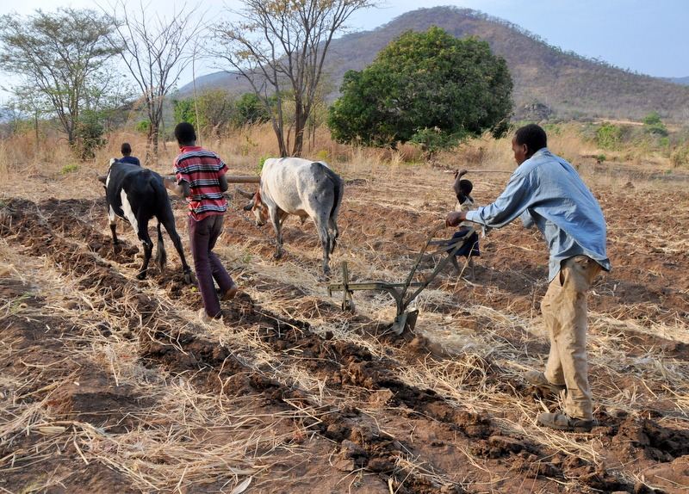
Small-scale farmer in Chipata, Zambia using the Magoye Ripper with oxen in a field protected from bush fires and with crop residues intact.

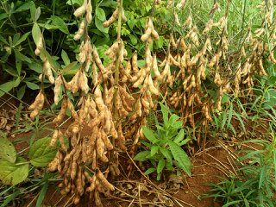
Soybean “giving crop” ready for harvesting. The roots which are left in the ground contain nodules rich in nitrogen. This feeds the next “taking crop.”

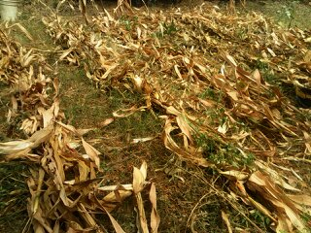
Maize residues in the field after harvest. The residues are protected from bushfires by a firebreak. They protect the ground from hot sun during the dry season and decompose to improve soil fertility.*

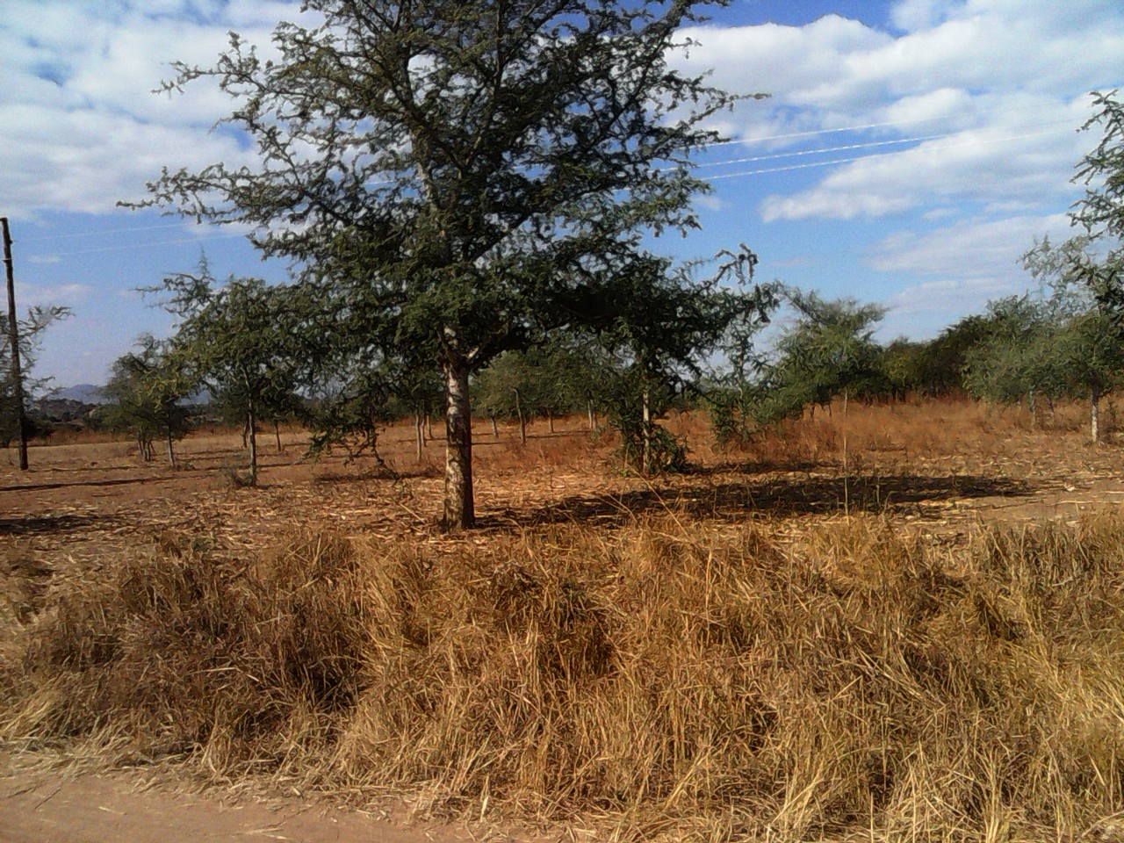
Seven-year-old Faidherbia albida at Kalunga Farmer Training Center, Chipata, Zambia. Planted ten metres apart, the boughs of the trees cover the whole field and drop their leaves to become nitrogen-rich humus. During the farming season, the trees are leafless and do not shade the crops.

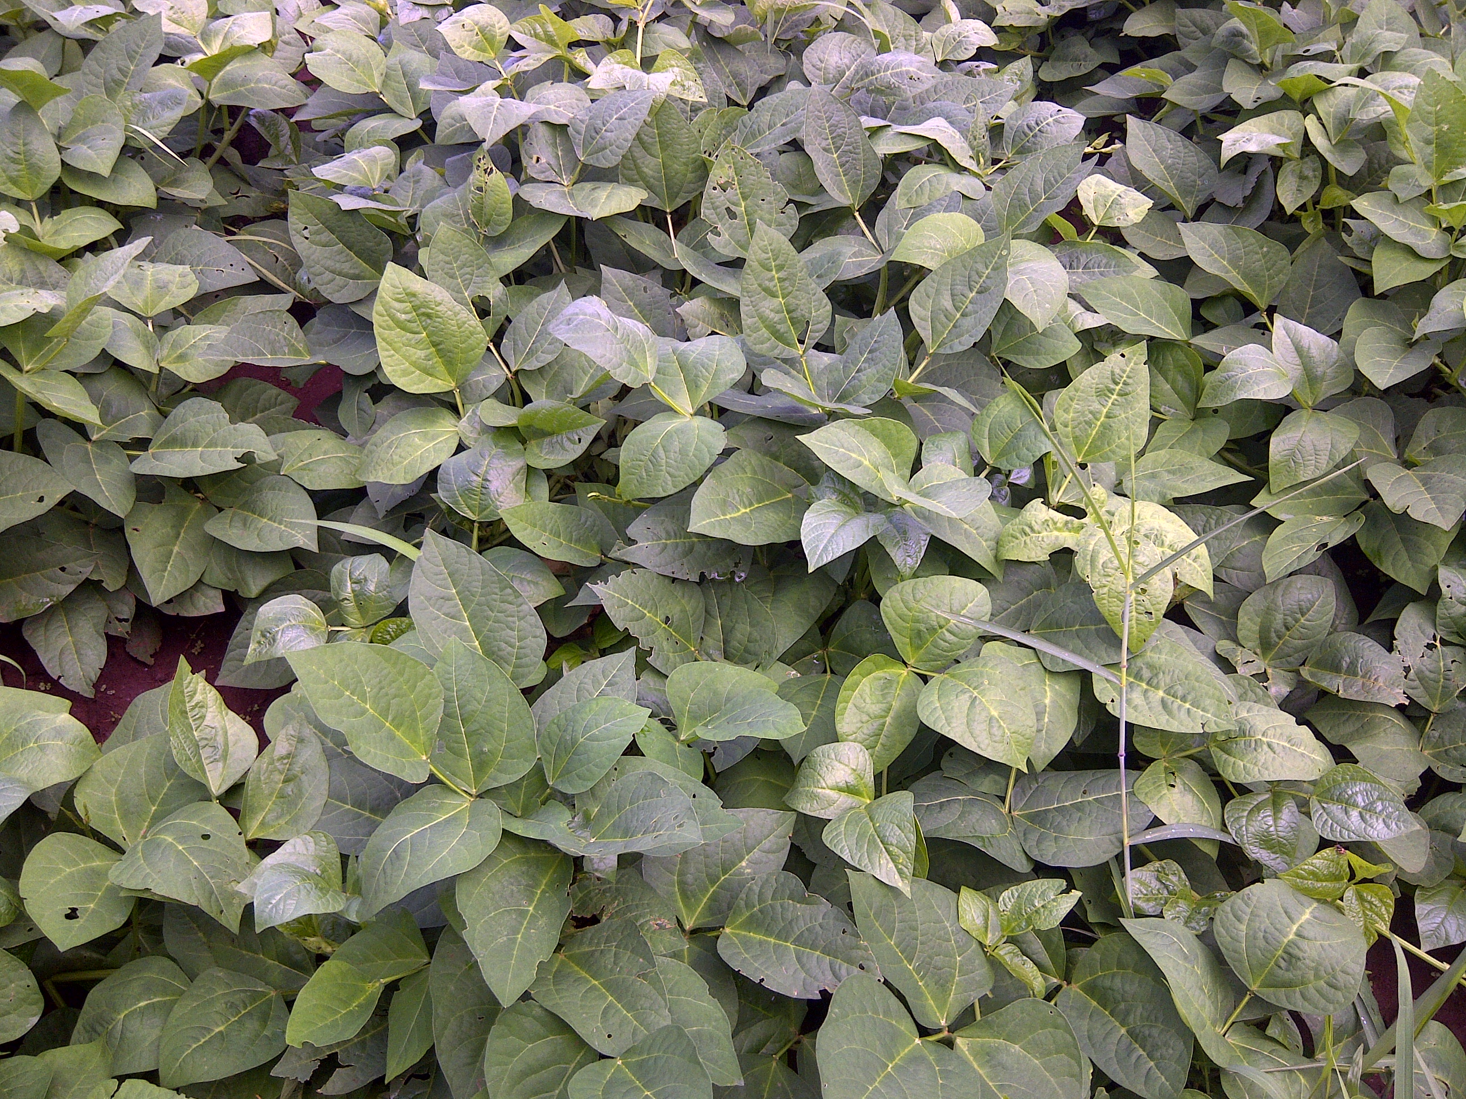
Cowpeas as a cover crop. The soil is completely protected from the impact of raindrops and wind. The crop also adds nitrogen to the soil.

Key definitions
Agroforestry: Incorporating useful trees and shrubs to enhance farming. Popular agroforestry species include: Faidherbia albida, Sesbania sesban, Tephrosia vogelii, Grevillia robusta, and Gliricidia sepium.
Cover crop: Crop grown to protect a field from the elements by covering bare soil. Popular cover crops include cowpeas, pigeon peas, and lablab.
Crop residues or trash: Post-harvest residues, for example, maize stover and groundnut haulms.
Crop rotation: Systematic alternation of crops in a field. Often, a crop that adds nutrients to the soil, for example, groundnuts, is followed by a crop like maize that requires a lot of soil nutrients.
Fallow: A piece of land that is left idle for a period of time, usually to allow soil fertility to rejuvenate.
“Giving crops”: Crops that add nutrients such as nitrogen to the soil. Most are legumes, which have nodules on their roots that contain nitrogen. When harvested by cutting above the ground instead of uprooting, the nodules are left in the soil and enrich it with nitrogen.
Hardpan: Compacted, hard layer of soil that develops under the soil surface after years of turning the soil with hand hoes or ploughs. This results in rainwater runoff and roots failing to reach deep into the soil.
Improved fallow: Fallowed fields planted with soil-improving, multi-use agroforestry species that shorten the fallow period so that land can be used more quickly. These species also provide economic and other benefits in the meantime, for example, fruit and firewood.
Land tenure: In this context, land tenure relates to the rules and regulations that govern access and ownership of land by small-scale farmers. In some countries in SSA, this mostly disadvantages married women who are sometimes regarded as secondary partners in a marriage. If not married, they are, nevertheless, considered as secondary citizens in some male-dominated communities.
Minimum tillage: Decreased turning of the soil during tillage. Minimum tillage encourages farmers to open the soil only where the plant will be sown. The rest of the land is left intact and relatively safe from the elements.
Mono-cropping: Growing one crop in a particular field year in and year out. Often leads to depletion of soil nutrients and buildup of crop pests and diseases.
Soil tilth: The condition of the soil. Soil with good tilth is soft and friable. “Friable” soil is soil that easily breaks into powder. Crop roots can easily penetrate such soils. Depleted soil may be brittle and dry and difficult for crop roots to penetrate.
“Taking crops”: Crops that depend on extracting existing soil nutrients or external inputs to grow.

Acknowledgements
Contributed by: Filius Chalo Jere, Farmer Program Producer, Breeze FM, Chipata, Zambia
Reviewed by: Neil Rowe Miller, Conservation Agriculture, Technical Officer, Mennonite Central Committee, and Godfrey Magoma, Conservation Agriculture Technical Specialist, Tanzania, Canadian Food Grains Bank, East Africa Conservation Agriculture Scale up Program

Sources of information:

Conservation Farming Unit website.conservationagriculture.org/
- Stephen Kabwe and Cynthia Donovan, 2005. The Magoye Ripper: Preliminary Findings On Adoption, Benefits, and Constraints. fsg.afre.msu.edu/zambia/GartYearbookdraftarticle_ripper.pdf
- Conservation Farming Unit. Faidherbia albida, undated. conservationagriculture.org/uploads/pdf/CA-AND-FAIDHERBIA-ALBIDA.pdf
- Conservation Technology Information Center, Purdue University. Crop residue management.www.ctic.purdue.edu/resourcedisplay/298/
- Wikipedia: Crop rotation: https://en.wikipedia.org/wiki/Crop_rotation
- Wikipedia: Cover crops: https://en.wikipedia.org/wiki/Cover_crop
- Food and Agriculture Organization of the United Nations (FAO), 2002. Land tenure and rural development. www.fao.org/docrep/005/y4307e/y4307e05.htm
All photos by Filius Chalo Jere, Breeze FM, Chipata, Zambia, with the exception of the first, by Par Oscarsson, Land Management and Conservation Farming Programme, Ministry of Agriculture, Zambia Sida/Orgut.
Project undertaken with the financial support of the Government of Canada through Global Affairs Canada (GAC)

